Name of company: Meridian Real Estate & Construction

Page Names: ABOUT, RESIDENTIAL, COMMERCIAL, HOSPITALITY & RETAIL

Note: Use one of the logo for Meridian Real Estate & Construction; whichever fits well with website design
Note: Create Dummy contact form as discussed
Note: Remove “prestige” anywhere on the website you create, there should be no trace of it
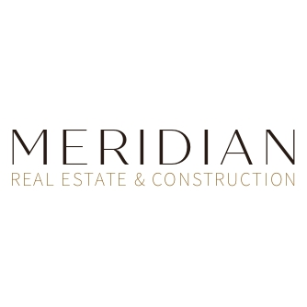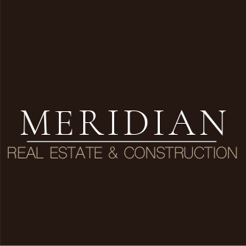

About Page
- About Us
About Meridian Real Estate & Construction
Remove the “Crisil … “ part
Over the last five decades, Meridian Real Estate & Construction, the flagship realty arm of privately held international business group, has firmly established itself as one of the leading and most respected developers across India, Singapore and the GCC (Qatar, Kuwait, Oman, KSA, UAE, Bahrain).

Founded in the early 1970s by C.V. Narayanan, the Meridian has been driven by a professional leadership team with deep experience in real estate, infrastructure and investments. Over time, the Group has strategically diversified into complementary businesses, each led by seasoned specialists. Its portfolio today in real estate spans interior design & fit-outs, facilities management, engineering services, and property advisory, alongside hospitality and retail ventures. This integrated ecosystem allows Meridian to offer end-to-end solutions, from land acquisition and master planning to construction, interiors and long-term asset management.

Meridian delivers a balanced mix of residential, commercial, retail, leisure and hospitality developments, including premium housing communities, integrated townships, Grade-A office spaces, destination malls and mixed-use developments.

The Meridian has successfully completed 6,500+ projects spanning a development area of 900+ million sqft and has 167 ongoing projects across segments, with a development area of 240+ million sqft currently under development. Across its portfolio, Meridian oversees a total project value exceeding $12 billion and holds a land bank of over 3500 acres as of July-18. The company has been graded CRISIL DA1+ and enjoys a credit rating of ICRA A+.

- Figures (on the left side)
50+
Years of Excellence

6500+
Projects Completed

900+
Million Sq. Ft. Delivered

240+
Million Sq. Ft. Underway

$12+
Billion Total Project Value (FY25-26)

- Remove - history timeline

- THE Meridian MARQUEE
Landmark Developments
- First row: Keep these following projects and their names, search in google for images
  - The collection at UB City -> take pic of UB city
Mixed development
  - ITC Grand -> take pic of ITC grand chola Chennai
Luxury hotel
- Meridian Grandeur -> take pic from this link https://sanjaypuriarchitects.com/architecture/township/the-pearl-oman/
Integrated township
- Meridian golfpearl -> take pic of prestige golfshire
18 hole championship golfcourse
- Meridian towers -> take pic from this link https://www.prestigesraintreepark.info/ultra-luxury-apartments-in-bangalore-2024.html
Ultra luxury residences
- Windsor -> take pic from this link
https://www.squareyards.com/bangalore-residential-property/spectra-reserve/325125/project
Luxury apartments

- Second row:
Residential : Shaping the skylines of commercial business districts in major cities of South East Asia and GCC
  - Meridian Prestige Lakeside Seaview Habitat
Large townships -> keep the pic used in the reference website
  - Prestige Falcon City
Integrated townships -> keep the pic used in the reference website
  - Prestige Jindal Techno City
Large townships -> keep the pic used in the reference website
  - Prestige Acropolis Meridian Athenes
Residential community -> keep the pic used in the reference website
  - Lakeview Luxe Villas
Luxury residences -> keep the pic used in the reference website
Commercial : Shaping the skylines of commercial business districts in major cities of South East Asia and GCC
- Tech park -> take pic from here https://www.nadalshibaconsultants.com/portfolio-item/kwait-industrial/
- Innovation town -> take pic from reference website from commercial part
- Trident -> take pic from reference website from commercial part
- Hydrogen industrial development -> take pic from this website https://www.steelradar.com/en/vulcan-green-steel-omans-hydrogen-powered-steel-plant-underway/
- Techno cloud -> take pic from reference website from commercial part

Hospitality & Retail : Shaping the skylines of commercial business districts in major cities of South East Asia and GCC
- JW Mariott -> take pic from reference website from hospitality part of JW marriott bengaluru prestige golfshire
- The Leela -> take pic from the link https://www.theleela.com/the-leela-palace-bengaluru
- ITC Taj -> take pic from the link https://www.itchotels.com/in/en/itcmughal-agra
- ITC Collection -> take pic from here https://www.bwhotelier.com/article/indian-hotels-beats-itc-to-retain-taj-mansingh-161084
- Meridian Gulf -> take pic from here
https://www.modabahrain.com/moda-mall-announces-new-luxury-and-prestige-outlets/
- Meridian Transpire -> take pic from here
https://www.tripadvisor.com/Attraction_Review-g297586-d8097770-Reviews-The_Forum_Sujana_Mall-Hyderabad_Hyderabad_District_Telangana.html

6. THE LEADERSHIP
TEAM
- Mouli Chaudhary (Chairman & Executive Director; Member of Management Board) -> Use pic below
- Abhishek Chaudhary (Non Executive Director; Member of Management Board) -> Use my pic below

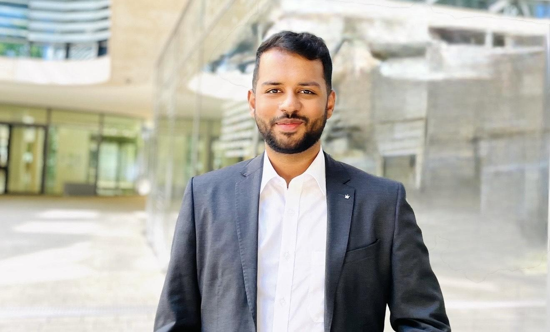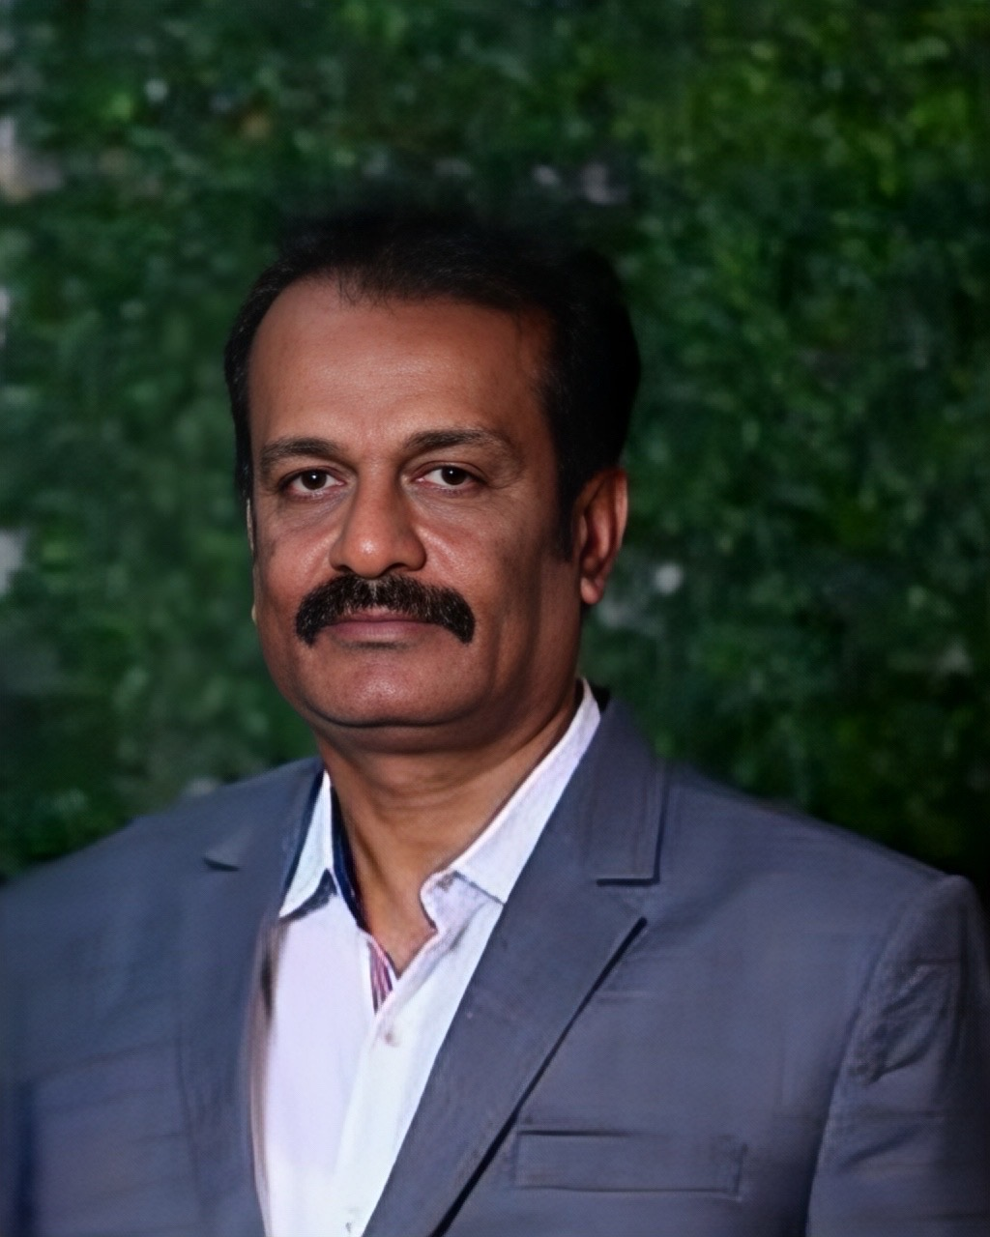

7. Ready to Experience Presitige Meridian?
Connect with our team to explore our diverse portfolio of residential, commercial, hospitality & retails projects, and find your perfect space.

Contact us -> should take to dummy form

7. Bottom / footnote section:
- Quick Menu -> About US, …
- Legal, Compliance & Data protection -> from your previous project, change to Meridian
- © 2025 Official Website of Meridian Real Estate & Construction Ltd. | All Rights Reserved.

Residential Page

Instruction:
- Add 30-40 projects from the reference website
- Give different names for each project. Use the names I have provided below for the projects
- Remove logos on the images; e.g., Prestige - remove it
- Make the price in dollars (where there is price) - If it is 3.48 crore onwards, make it $348k onwards
- Change project locations - Just keep the country name; for 12 projects name it India, 10 projects name it Oman, 8 projects name it Kuwait, 4 projects name it Qatar, 3 projects name it Saudi, 3 projects name it Singapore
- In the left side “All Properties”: the split of projects by country needs to be shown (e.g., India - 12 Projects Available, Kuwait ..)

Names
Meridian SkyCourt Residences
Cedarstone Residency
Meridian Crestview Towers
Azure Grove Homes
Meridian Palm Grove
Skyline Aurelia
Meridian Cityscape Residences
Coralwood Estate
Meridian Lotus Park
Riverbend Residences
Meridian Opal Ridge
Amber Oaks Residency
Meridian Harmony Homes
Ivory Bay Residences
Meridian Greenstone Enclave
Suncrest Avenue
Meridian Eden Springs
Willowstone Gardens
Meridian Nova Homes
Maplebrook Homes
Meridian Sapphire Residency
Urban Vista Residences
Meridian Lakefront Residences
Crescent Meadows
Meridian Valley Crest Villas
Horizon Springs
Meridian Urban Crest
Aurora Parkside
Meridian Vertex Living
Grand Elm Enclave
Meridian Magnolia Court
Palmcrest Gardens
Meridian Maple Heights
Silverleaf Residences
Meridian Crown Vista
Opaline Heights
Meridian Grand Arcadia
Lakeview Serenade
Meridian Azure Heights
Crownleaf Villas

Commercial Page

Instruction:
- Add 15-20 projects from the reference website
- Give different names for each project. Use the names I have provided below for the projects
- Remove logos on the images; e.g., Prestige - remove it
- Change project locations - Just keep the country name; for 7 projects name it India, 4 projects name it Oman, 5 projects name it Kuwait, 2 projects name it Qatar, 2 projects name it Saudi
- In the left side “All Properties”: the split of projects by country needs to be shown (e.g., India - 12 Projects Available, Kuwait ..)
- Remove compliance document section in the end of page

Names:
Meridian Business Square
Orion TechPoint
Meridian Commerce Hub
Nova Corporate Center
Meridian Infinity Park
Axis Tower One
Meridian Trade Centre
Skyline Business Plaza
Meridian TechVista
Harbour Edge Offices
Meridian Capitol Towers
Crestline Business Park
Meridian Orion Chambers
Urban Gate Corporate Park
Meridian Metro Plaza
Vertex Business Bay
Meridian Prime Towers
Centrum IT Park
Meridian Boulevard Offices
Gateway Commercial Centre

Hospitality & Retail Page

Instruction:
- Add these projects from Hospitality & retail page into one Hospitality & retail page:
- From hospitality page take these:
  - Sheraton Grand
  - JW Mariott
  - Angsana Oasis & Spa - Rename to Bayfront Suites
  - Resort & Spa in Whitefield - Rename to Resort & Spa in Goa
  - ITC Taj -> take pic from the link https://www.itchotels.com/in/en/itcmughal-agra
  - ITC Collection -> take pic from here https://www.bwhotelier.com/article/indian-hotels-beats-itc-to-retain-taj-mansingh-161084
  - Meridian Gulf -> take pic from here
https://www.modabahrain.com/moda-mall-announces-new-luxury-and-prestige-outlets/
- From retail page take these:
  - Forum south bangalore - Rename to Forum
  - The collection at UB city - Rename to The collection
- Make the names the way I have mentioned
- Remove location from the place e.g., Bangalore - remove it if it is present

